**Unit 4 cheat sheet**

Concept summary:

https://csawesome.runestone.academy/runestone/books/published/csawesome/Unit4-Iteration/topic-4-6-summary.html

While Loops:

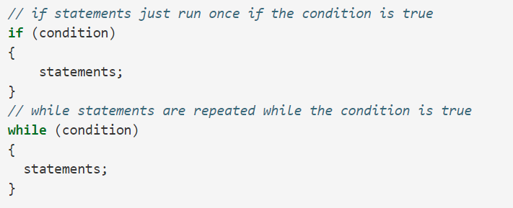

Counter Controlled While Loops:

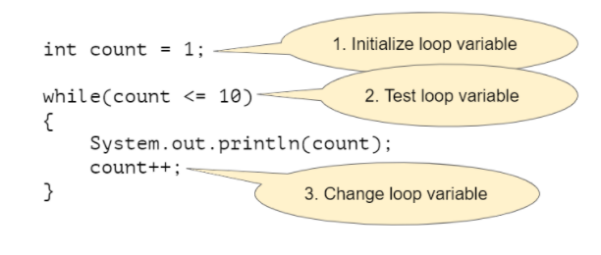

Input Controlled While Loops:

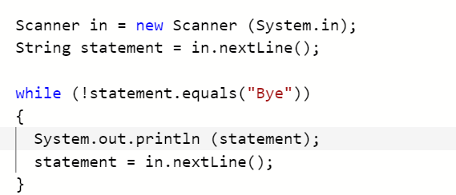

*common errors include Infinite Loops and Off-by-one loops. Use Trace tables to track loop

For Loops:

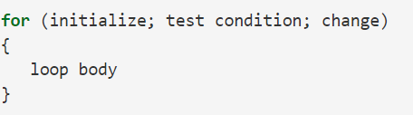

*There are three parts in a for loop header: the initialization, the test condition (a Boolean expression), and an increment or decrement statement to change the loop control variable.

*In a for loop, the initialization statement is only executed once before the evaluation of the test Boolean expression. The variable being initialized is referred to as a loop control variable.

*In each iteration of a for loop, the increment or decrement statement is executed after the entire loop body is executed and before the Boolean expression is evaluated again.

*initialization statement and test condition can be left blank and down within the body or outside the loop

Nested Loops:

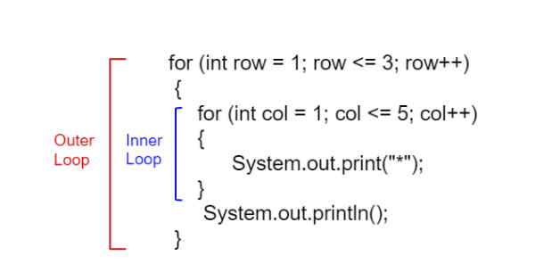

*inner loop is completed before the outer loop iteration can be continued.

Find and Replace Loop:

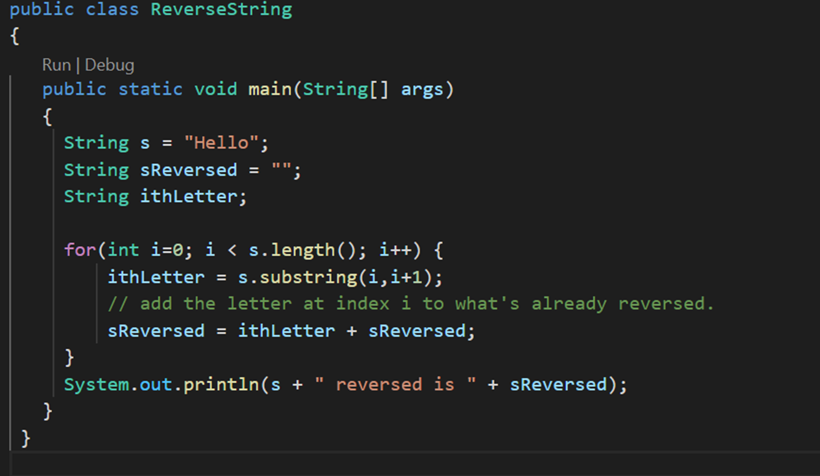

Reverse String Loop:



Switch:

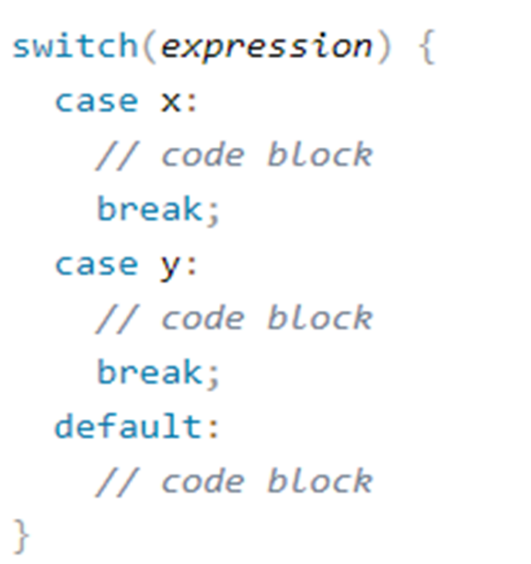

*When Java reaches a break keyword, it breaks out of the switch block.

*The default keyword specifies some code to run if there is no case match.

Character Class:

*When we work with characters, we use the primitive data type char.

*In Java characters have Unicode values.

*Some situations are easier if we use the wrapper class Character instead of a primitive data type.

*Creating a character object is similar to creating other objects.

*When using Character methods on char data types, the compiler will normally auto “translate” them into objects.

Common methods:

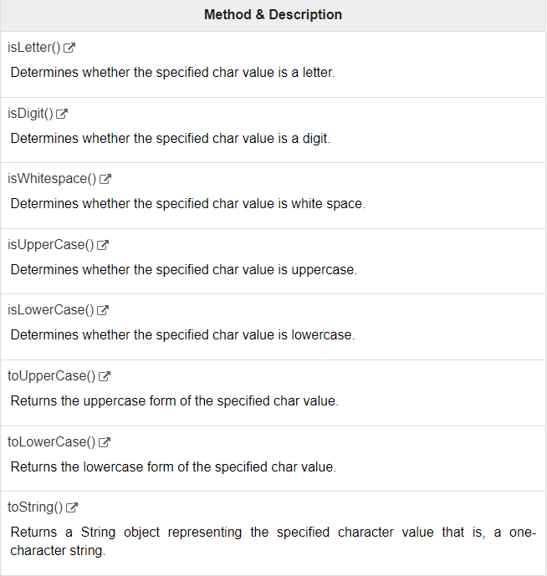

compareTo() method

*part of the string class

*The comparison is based on the Unicode value of each character in the strings.

*The method returns 0 if the string is equal to the other string. A value less than 0 is returned if the string is less than the other string (less characters) and a value greater than 0 if the string is greater than the other string (more characters).

